# Part 1



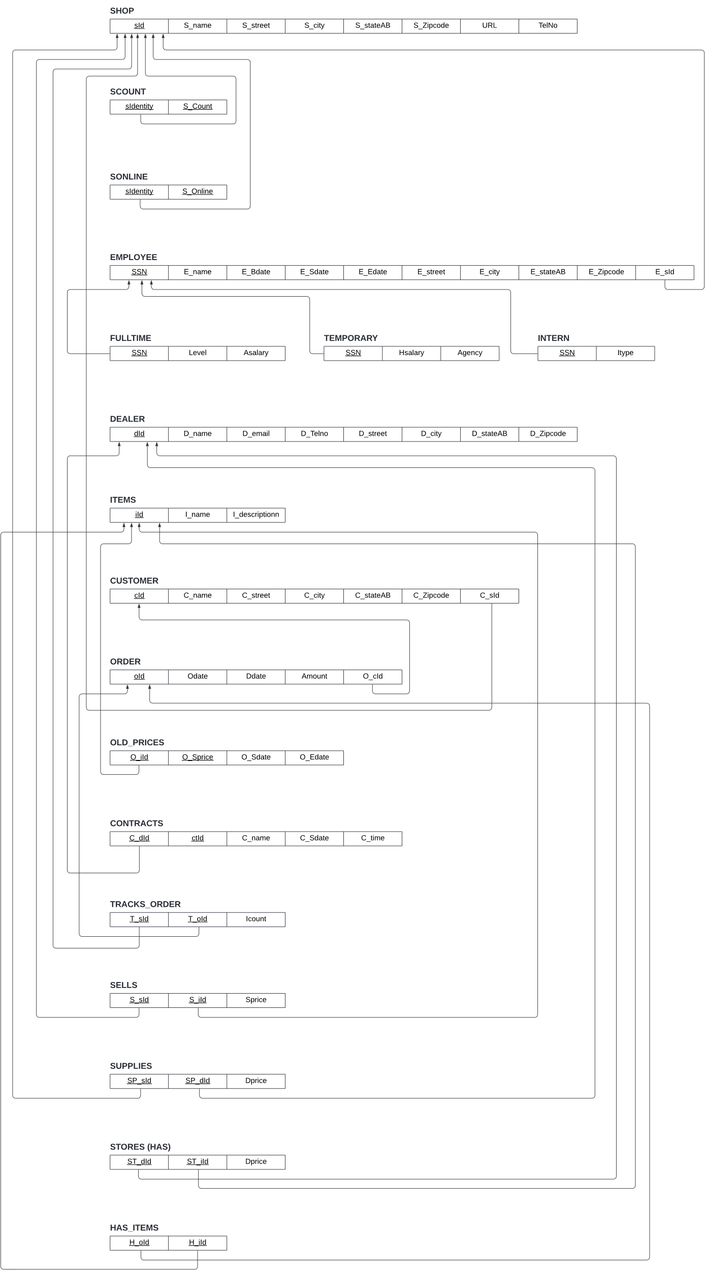

# Part 2

CREATE TABLE SHOP (

sId INT PRIMARY KEY,

Sname VARCHAR(255) NOT NULL,

Street VARCHAR(255),

City VARCHAR(255),

StateAb CHAR(2),

ZipCode VARCHAR(10),

Sdate DATE,

Telno VARCHAR(15),

URL VARCHAR(255)

);

SELECT * FROM `shop`



CREATE TABLE DEALER (

dId INT PRIMARY KEY,

Dname VARCHAR(255) NOT NULL,

Street VARCHAR(255),

City VARCHAR(255),

StateAb CHAR(2),

Zipcode VARCHAR(10)

);

SELECT * FROM `dealer`

CREATE TABLE DEALER_SHOP (

dId INT,

sId INT,

PRIMARY KEY (dId, sId),

FOREIGN KEY (dId) REFERENCES DEALER(dId),

FOREIGN KEY (sId) REFERENCES SHOP(sId)

);

SELECT * FROM `dealer_shop`

CREATE TABLE CONTRACT (

dId INT,

ctId INT,

Sdate DATE,

Ctime TIME,

Cname VARCHAR(255),

PRIMARY KEY (ctId, dId),

FOREIGN KEY (dId) REFERENCES DEALER(dId)

);

SELECT * FROM `contract`

CREATE TABLE ITEM (

iId INT PRIMARY KEY AUTO_INCREMENT,

Iname VARCHAR(255) NOT NULL,

Sprice DECIMAL(10, 2) NOT NULL

);

SELECT * FROM `item`

CREATE TABLE DEALER_ITEM (

dId INT,

iId INT,

dprice DECIMAL(10, 2) NOT NULL,

PRIMARY KEY (dId, iId),

FOREIGN KEY (dId) REFERENCES DEALER(dId),

FOREIGN KEY (iId) REFERENCES ITEM(iId)

);

SELECT * FROM `dealer_item`

CREATE TABLE OLDPRICE (

iId INT,

Sprice DECIMAL(10, 2) NOT NULL,

Sdate DATE,

Edate DATE,

PRIMARY KEY (iId, Sdate),

FOREIGN KEY (iId) REFERENCES ITEM(iId)

);

SELECT * FROM `oldprice`

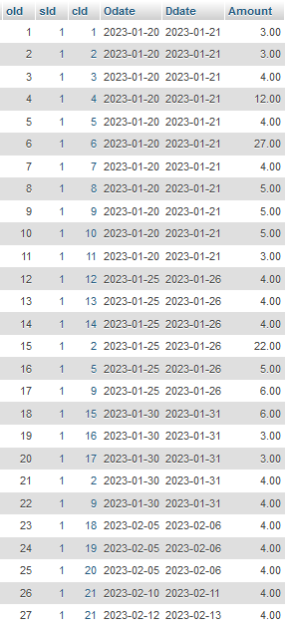CREATE TABLE `ORDER` (

oId INT,

sId INT,

cId INT NOT NULL,

Odate DATE,

Ddate DATE,

Amount DECIMAL(10, 2) NOT NULL,

PRIMARY KEY (oId, sId),

FOREIGN KEY (sId) REFERENCES SHOP(sId),

FOREIGN KEY (cId) REFERENCES CUSTOMER(cId)

);

SELECT * FROM `order`

CREATE TABLE ORDER_ITEM (

oId INT,

sId INT,

iId INT,

Icount INT NOT NULL,

PRIMARY KEY (oId, sId, iId),

FOREIGN KEY (oId) REFERENCES `ORDER`(oId),

FOREIGN KEY (sId) REFERENCES SHOP(sId),

FOREIGN KEY (iId) REFERENCES ITEM(iId)

);

SELECT * FROM `order_item`

CREATE TABLE SHOP_ITEM (

sId INT,

iId INT,

Scount INT NOT NULL,

PRIMARY KEY (sId, iId),

FOREIGN KEY (sId) REFERENCES SHOP(sId),

FOREIGN KEY (iId) REFERENCES ITEM(iId)

);

SELECT * FROM `shop_item`

CREATE TABLE CUSTOMER (

cId INT PRIMARY KEY,

Cname VARCHAR(255) NOT NULL,

Street VARCHAR(255),

City VARCHAR(255),

StateAb CHAR(2),

Zipcode VARCHAR(10)

);

SELECT * FROM `customer`

CREATE TABLE SHOP_CUSTOMER (

sId INT,

cId INT,

PRIMARY KEY (sId, cId),

FOREIGN KEY (sId) REFERENCES SHOP(sId),

FOREIGN KEY (cId) REFERENCES CUSTOMER(cId)

);

SELECT * FROM `shop_customer`

CREATE TABLE EMPLOYEE (

sId INT,

SSN VARCHAR(11),

Ename VARCHAR(255) NOT NULL,

Street VARCHAR(255),

City VARCHAR(255),

StateAb CHAR(2),

Zipcode VARCHAR(10),

Etype VARCHAR(255),

Bdate DATE,

Sdate DATE,

Edate DATE,

Level VARCHAR(255),

Asalary DECIMAL(20, 2),

Agency VARCHAR(255),

Hsalary DECIMAL(20, 2),

Institute VARCHAR(255),

Itype VARCHAR(255),

PRIMARY KEY (SSN, sId),

FOREIGN KEY (sId) REFERENCES SHOP(sId)

);

SELECT * FROM `employee`

# Part 3

1. Retrieve the names and the address of all the customers whose last names start with a 'J' or 'M'.

SELECT Cname, Street, City, StateAB, Zipcode

FROM CUSTOMER

WHERE Cname LIKE '% J%' OR Cname LIKE '% M%'

1. State the names of dealers, the courses that they offer, the date, and the time at which they offer the courses after 2:00 PM. Display the time in 12-hour AM/PM format. (Hint: CONTRACT table provides the course details; Note: Dealers are also known as Vendors for this and all the following queries)

SELECT

Dname AS `Vendor Name`,

Cname AS `Course Name`,

Sdate AS `Course Date`,

TIME_FORMAT(Ctime, '%r') AS `Course Time`

FROM DEALER

NATURAL JOIN CONTRACT

WHERE Ctime > '14:00:00'

1. Retrieve the names of the dealers, the items that they supply, and the price at which they supply these at. Additionally, list the price at which the Shop sells these items. (Note: Shop and Store mean the same going forward in this and subsequent queries).

SELECT

Dname

Iname,

CONCAT('$', FORMAT(dprice, 2)) AS `Vendor Price`,

CONCAT('$', FORMAT(Sprice, 2)) AS `Store Price`

FROM DEALER

NATURAL JOIN DEALER_ITEM

NATURAL JOIN ITEM

1. Retrieve the names of the 10 most expensive items sold at the shop. List the items in descending order by price and the item names in ascending order for each price point. The dollar amount should be stated with $, appropriate commas, and up to 2 decimal places. (Ex: $12,000.00)

SELECT

Iname AS `Item Name`,

CONCAT('$', FORMAT(Sprice, 2)) AS `Store Price`

FROM ITEM

ORDER BY Sprice DESC, Iname ASC

LIMIT 10;

1. Retrieve the dealer names, item names, dealer prices, and the shop prices when the shop charges more than double the dealer price. The dollar amount should be stated with $, appropriate commas, and up to 2 decimal places. (Ex: $12,000.00)

SELECT

Dname AS Vname,

Iname,

CONCAT('$', FORMAT(dprice, 2)) AS `Vendor Price`,

CONCAT('$', FORMAT(Sprice, 2)) AS `Store Price`

FROM DEALER

NATURAL JOIN DEALER_ITEM

NATURAL JOIN ITEM

WHERE Sprice > 2 * dprice

1. Retrieve the dealer names, item names, dealer prices, and the shop prices when the shop and the dealer prices differ by exactly 2 dollars. Order the results by Dealer Names. The dollar amount should be stated with $, appropriate commas, and up to 2 decimal places. (Ex $12,000.00)

SELECT

Dname AS `Vendor Name`,

Iname AS `Item Name`,

CONCAT('$', FORMAT(dprice, 2)) AS `Vendor Price`,

CONCAT('$', FORMAT(Sprice, 2)) AS `Store Price`

FROM DEALER

NATURAL JOIN DEALER_ITEM

NATURAL JOIN ITEM

WHERE ABS(dprice - Sprice) = 2

ORDER BY Dname;

1. 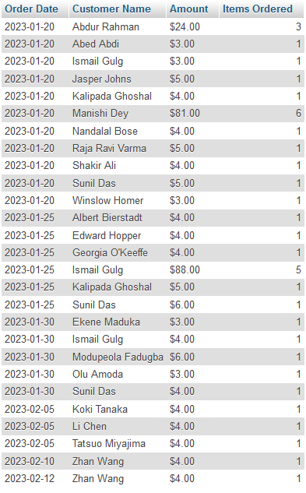Retrieve a list of date, customer name, the total order amount, and the number of items bought by them. Let the list be sorted in an ascending order by date and the customers’ names. The dollar amount should be stated with $, appropriate commas, and up to 2 decimal places. (Ex: $12,000.00)

SELECT

O.Odate AS `Order Date`,

C.Cname AS `Customer Name`,

CONCAT('$', FORMAT(SUM(O.Amount), 2)) AS `Amount`,

SUM(OI.Icount) AS `Items Ordered`

FROM

`ORDER` AS O, CUSTOMER AS C, ORDER_ITEM AS OI

WHERE

O.cId = C.cId AND O.oId = OI.oId AND O.sId = OI.sId

GROUP BY

O.Odate, C.Cname

ORDER BY

O.Odate ASC, C.Cname ASC;

1. Retrieve the total, average, maximum amounts of order placed in the shop so far by date. The price should be stated with $, appropriate commas, and up to 2 decimal places. (Example: $12,000.00)

SELECT

Odate AS `Order Date`,

CONCAT('$', FORMAT(SUM(Amount), 2)) AS `Sum AMT`,

CONCAT('$', FORMAT(AVG(Amount), 2)) AS `Avg AMT`,

CONCAT('$', FORMAT(MAX(Amount), 2)) AS `Max AMT`

FROM `ORDER`

GROUP BY Odate

1. A table with many different names

   Description automatically generated with medium confidenceRetrieve a list of records that lists the name of customers and the sum of all the orders that they have ever placed at any of the Shops. List the records in an ascending order by the total amount spent by customers at the shop. The dollar amount should be stated with $, appropriate commas, and up to 2 decimal places. (Ex: $12,000.00)

SELECT

Cname AS `Customer Name`,

CONCAT('$', FORMAT(SUM(Amount), 2)) AS `Total Amount Spent`

FROM CUSTOMER

NATURAL JOIN `ORDER`

GROUP BY Cname

ORDER BY SUM(Amount) ASC;

1. Retrieve a list of records that lists the name of customers, the total number of items (aka boxes) they ordered at any time, and the sum of all the order amounts that they have ever placed at any of the shop. List the records in an ascending order by the total number of items (boxes) ordered at any time, followed by the total amount spent by customers at the shop. The dollar amount should be stated with $, appropriate commas, and up to 2 decimal places. (Example: $12,000.00)

SELECT

Cname,

SUM(Icount) AS `Total Boxes`,

CONCAT('$', FORMAT(SUM(Amount), 2)) AS `Total Amount`

FROM CUSTOMER

NATURAL JOIN `ORDER`

NATURAL JOIN ORDER_ITEM

GROUP BY Cname

ORDER BY `Total Boxes` ASC, `Total Amount` ASC;

1. Write and Execute a command to delete a record that violates any referential integrity constraint. List the command and State the message produced by the DBMS.

DELETE FROM DEALER WHERE dId = 1;

#1451 - Cannot delete or update a parent row: a foreign key constraint fails (`database`.`dealer_item`, CONSTRAINT `dealer_item_ibfk_1` FOREIGN KEY (`dId`) REFERENCES `dealer` (`dId`))

1. Write and Execute 3 insert commands for any table that attempt to insert records, such that the records violate the explicit schema-based constraints (Key, Entity Integrity, or Referential Integrity constraints). Make each of the 3 inserts violate a different type of integrity constraint. Include the insert statements and the error messages produced.
   1. Key Constraint

INSERT INTO CUSTOMER VALUES (1, 'John Doe', '123 Elm St', 'Anytown', 'TX', '12345');

#1062 - Duplicate entry '1' for key 'PRIMARY'

* 1. Entity Integrity Constraint

INSERT INTO DEALER VALUES (NULL, NULL, '789 Pine St', 'CityName', 'NY', '12345');

#1048 - Column 'dId' cannot be null

* 1. Referential Entigrity Constraint

INSERT INTO DEALER_SHOP VALUES (999, 1);  
  
#1452 - Cannot add or update a child row: a foreign key constraint fails (`database`.`dealer_shop`, CONSTRAINT `dealer_shop_ibfk_1` FOREIGN KEY (`dId`) REFERENCES `dealer` (`dId`))

1. Write and Execute an update command for SHOP_CUSTOEMR table that attempts to update records in child rows, such that the record violates the foreign key constraint. Include the update statement and the error message.

UPDATE SHOP_CUSTOMER SET sId = 999 WHERE cId = 1;  
  
#1452 - Cannot add or update a child row: a foreign key constraint fails (`database`.`shop_customer`, CONSTRAINT `shop_customer_ibfk_1` FOREIGN KEY (`sId`) REFERENCES `shop` (`sId`))

